**ASSIGNMENT-5**

Harsh Chandrakar PRN-250840125020

Q.2 Create an Account class Heirarchy

Account with super class (acc_id, name, balance)

methods - withdraw and deposit

Create SavingsAccount as sub class of account - additional field (type - personal/corporate etc)

implement withdraw and deposit such that

- maximum upto 1 lakh can be deposited in an account at a time

- Min balance 5000 must be maintained while withdrawal (if type = corporate you withdraw full amount = balance)

Create CurrentAccount as sub class of account

implement withdraw and deposit such that

- maximum upto 2 lakh can be deposited in an account at a time

- Min balance 10000 must be maintained while withdrawal

Create Bank App with Transaction class

Create Method withdraw_from_account(account : Account) and deposit_to_account(account : Account)

These methods will return the new balance after deposite/withdraw

Create user class with user interface that gives 2 menu options

1. Deposit

2. Withdraw

Both options will ask user to enter money to withdraw/deposite

Display a statement with each transaction and final balance after user exits from the menu

Identify possible Exceptions and implement them

**Bank.py**

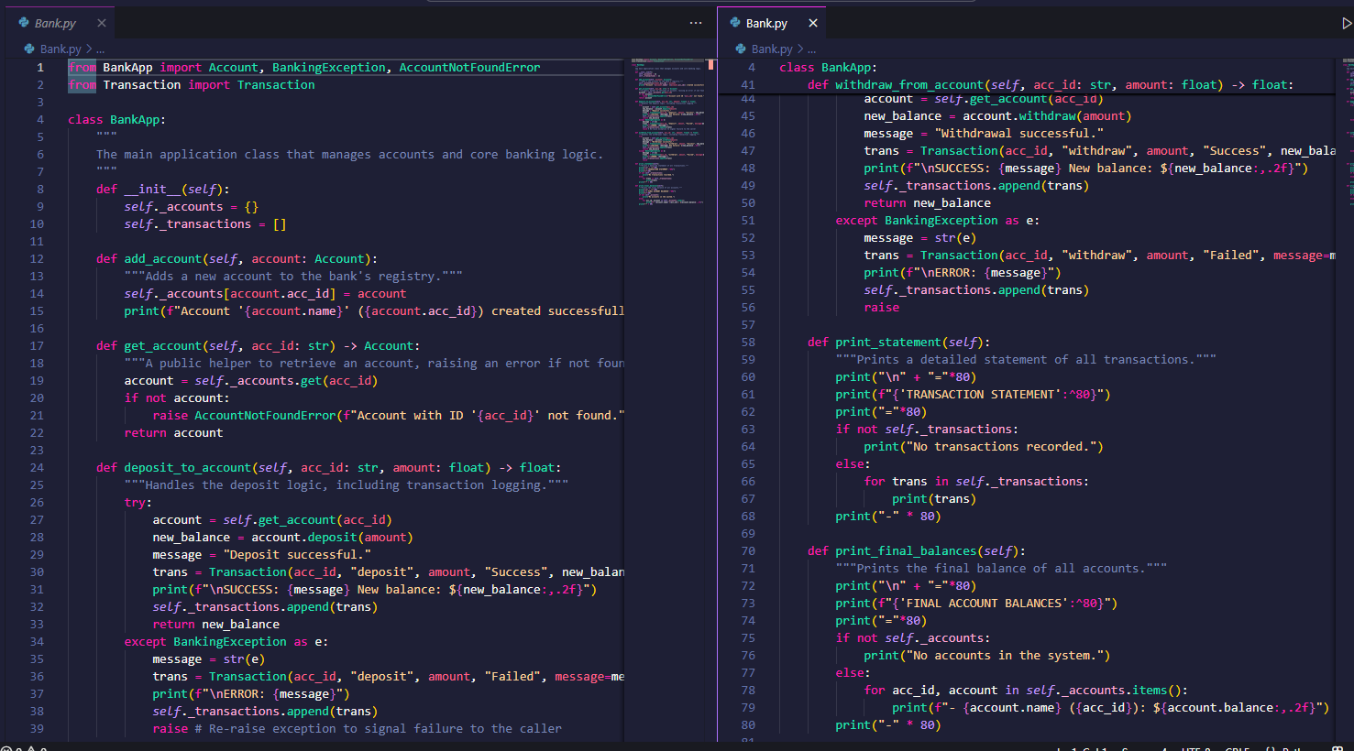

**BankApp.py**

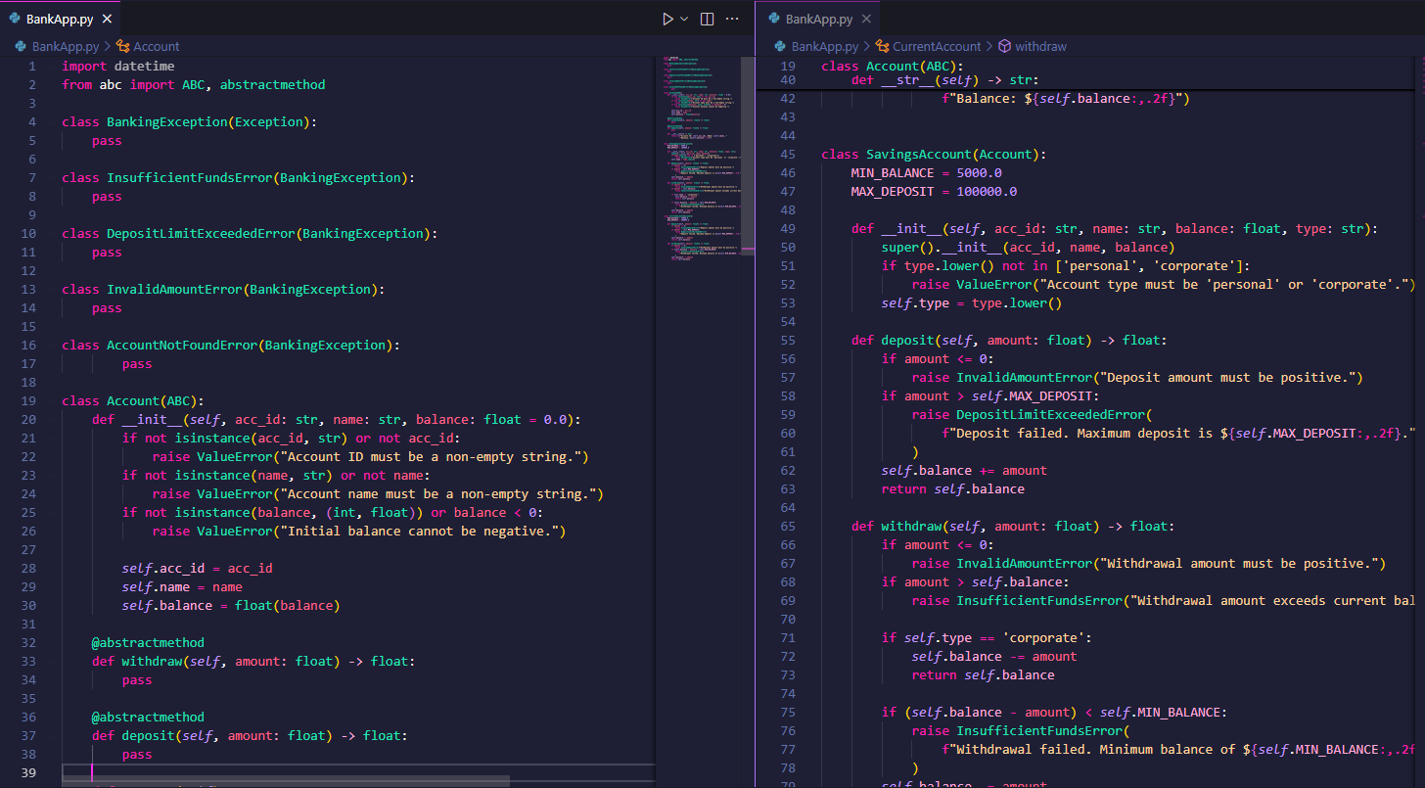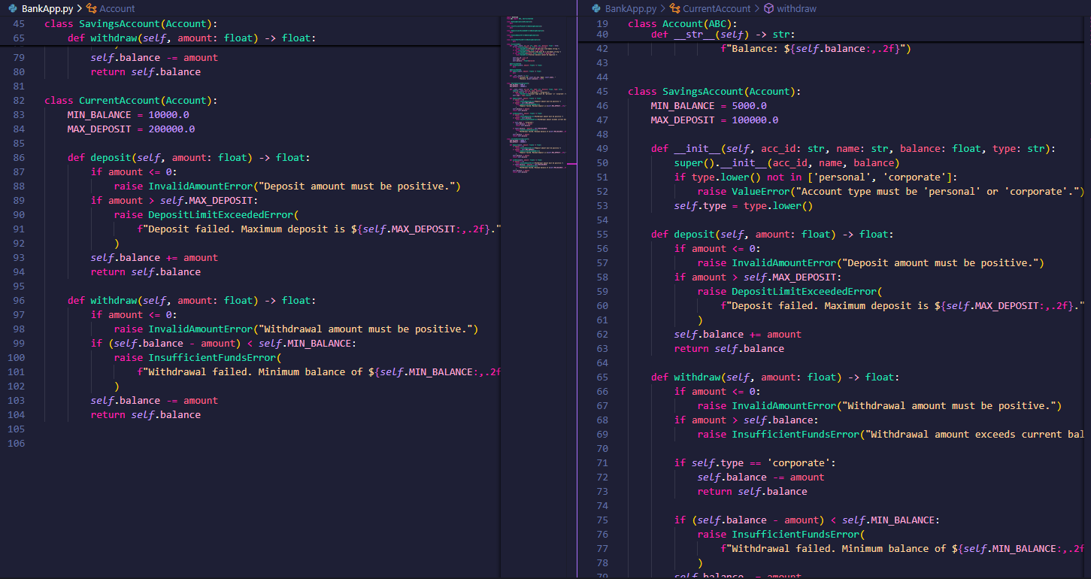

**Transactions.py**

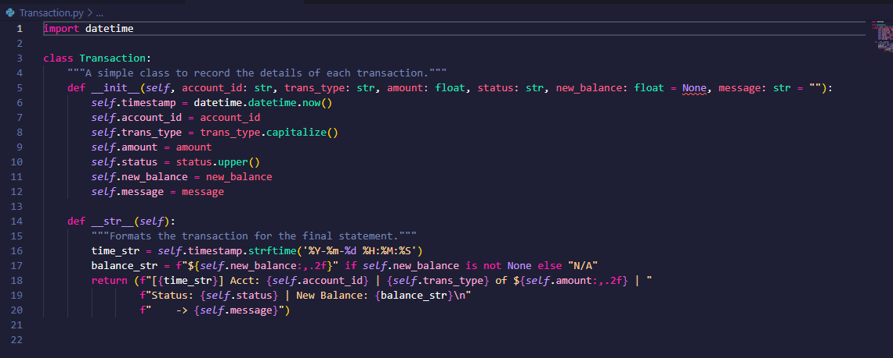

**Main.py**

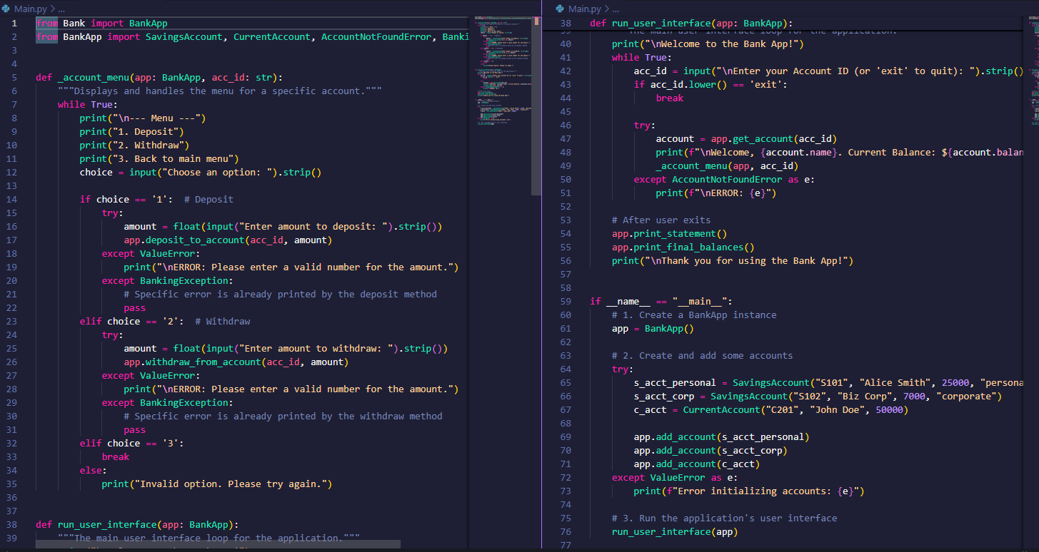

**OUTPUTS**

